
Formula Windsurfing World Championships
Airport Transfer Shuttle SCHEDULE

Sail Melbourne has received and compiled all requests for the Shuttle Bus from the Melbourne Tullamarine Airport to Elwood Sailing Club for sailors, their supporters and their equipment and now advise the following schedule of shuttle runs.

Please note the following very important logistical points for all people and equipment to be carried by the shuttle bus

WHERE TO MEET
International arrivals hall
Shuttle bus will be in here
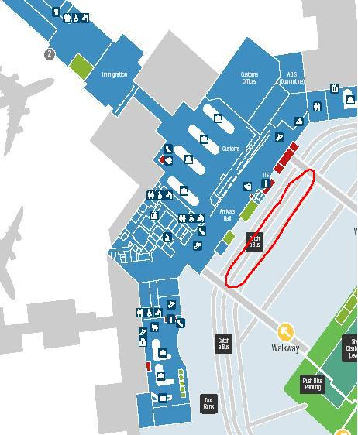
- We will be in a 12 seater mini bus with a Sail Melbourne logo on the side (refer above!) with a trailer attached on the back. The bus will be very temporarily parked in the 5 minute pick up and drop off driveway, outside, immediately opposite the International Arrivals Hall. Note – we will not be in the first drive way you get to when you leave the building as this is for Taxis only but in the next driveway, outside in the open.
- There is only one Terminal at the Melbourne Tullamarine Airport so this pick up spot is very close to where you arrive – no more than 100m away so don’t walk too far!
- If you arrive to Melbourne on a domestic flight from within Australia then please move to the same location explained above – outside the International Arrivals Hall.

WHEN TO MEET
- The Mini Bus and trailer will be there at the times listed below. We cannot leave the mini bus to come inside and find you so please make sure you are waiting outside in the area described above at exactly the time listed.
- Our shuttle runs are timed to rendezvous with sailors according to the times you told us you arrive plus additional time for you to get your bags and to go through customs and quarantine.
- We will only be running the shuttles runs listed below and have tried to match these up to the times sailors arrive. In order to collect the most number of people this will mean that some sailors will have to wait an hour or more to meet the bus but as some people arrive at slightly different times this is the best we can do.
- If your plane is delayed and/or you miss the bus you were scheduled to catch then please call the driver of the bus on +61 (0) 424 887 308 to tell us how late you will be. We may be able to wait or you may have to catch the next bus as we have a time schedule to run to and unfortunately cannot keep everybody waiting.

WHO TO MEET
- We have included below all the sailors who will be catching the same bus and to make it far easier for us, ask you to please find each other and wait together and in the one place rather than in different areas.
- Look for the 12 seater mini buss with a trailer attached with the Sail Melbourne sticker attached on the side. The driver of the bus may be contacted on +61 (0) 424 887 308.

We will take all people and sailing equipment straight to the Elwood Sailing Club where you will be able to store your equipment / go for a sail / meet others. We may be able to drop you at your accommodation depending upon where it is but make no promises on this regard. Most places are pretty close and are a short walk or taxi ride away.
The Shuttle runs will be free of charge for competitors in the Australian and/or World Championships and for non competitors we will charge $10 per trip. It takes approximately 30 minutes (depending upon traffic) to go from the Airport to the Sailing Club.

Listed below are all the names of people from whom we have received bookings for the shuttle. IF YOUR NAME IS NOT ON THIS LIST THEN AT THIS STAGE WE ARE NOT PICKING YOU UP!

Shuttle bus schedule departure times from Melbourne’s Tullamarine Airport :

Monday 5th December
Shuttle departure time Passengers Arriving from
10am Ertugrul Icingir (C) Dubai
Ilknur Icingir (S) Dubai
Kristian Olsen (C) Singapore
May-Liss Mathisen (S) Singapore
Hanne Mathisen (S) Singapore
Erik Mathisen (S) Singapore
Michael Porter (C) Los Angeles, CA

5.30pm Maris Smiltenieks (C) Wienna (Austria)
Aiga Zaharane (S) Wienna (Austria)
Elmars Smiltenieks (S) Wienna (Austria)
Romualds Zelcs (C) Wienna (Austria)
Agris Strautnieks (S) Wienna (Austria)
Signe Petersone (S) Wienna (Austria)

9.30pm Boramr (C) Izmir
Kozanoglu (S) Izmir
Iber (S) Izmir
Sanolmr (S) Izmir

Tuesday 6th December
Shuttle departure time Passengers Arriving from
1.30pm Devon Boulon (C) Sydney

9.30pm Johann Malaper (C) Paris/Bangkok
Aurelien Le Metayer (C) Paris/Bangkok
Aurelien Le Metayer (C) Paris/Bangkok

Wednesday 7th December
Shuttle departure time Passengers Arriving from
8.30am Lukasz Konieczny (C) Germany

2.30pm Mr Phanuthat Ruamsap (C) Bangkok
Mrs Napaporn Boonsawat (S) Bangkok
Mr Ake Boonsawat (C) Bangkok
Mr Kriangkri Sakuyang (C) Bangkok
Mr Pattana Boonsawat (S) Bangkok

10.30pm Dessau Thomas (C) Copenhagen
Larsen Kasper (C) Copenhagen
Rasmussen Kasper (C) Copenhagen
Honoré Bettina (C) Copenhagen
Antoine Albeau (C) Honolulu - Sydney - Melbourne
Sarah Sherwood (S) Honolulu - Sydney - Melbourne

Thursday 8th December
Shuttle departure time Passengers Arriving from
6.30am Daniel Engdahl (C) Perth

10.30pm Marco Begalli (C) Japan
Janis Preiss (C) LA-CA
Steve Bodner (C) Sydney

1pm Yuji Sugihara (C)

5.30pm Antoine Questel (c) Paris
Florent Renard (c) Paris
Julien Quentel (C) Paris

Friday 9th December
Shuttle departure time Passengers Arriving from
10.30pm Knut Thorkaas (C) Singapore
Jimmy Diaz (C) Sydney
Micah Buzianis (C) Sydney

If you have any questions in connection to the shuttle bus then please contact Sail Melbourne as addressed below. We have also received many requests for the return shuttle from the Club to the Airport after the event and will publish a similar schedule and details during the event that covers these movements.

See you at the airport!

------------------ --------------------- --------------------- --------------------- --------------------- --------------

MISS THE BUS?!
If you arrive before Monday December 5th or miss the bus and cannot get your equipment to the Elwood Sailing Club the following two Airport Shuttle bus companies will take you and your equipment to the Club and/or your accommodation in or near Elwood. You are supposed to book their service before you arrive but they may help you in times of an emergency.

Airport Shuttle Express
Contact Person: Danny
Phone: + 61 1300 767 001
Website: www.airportshuttlexpress.com.au
Airport Shuttle Express generally takes a booking per person however they are prepared to take a bus of up to 5 people including trailer for AUD $55.00. They are also able to help if teams have more than 5 passengers.

Melbourne Chauffer Driven Limo and Buses
Contact Person: David or Kathy
Email: justit@bigpond.com
Phone: + 61 3 9364 9994
Mobile: + 61 417 568 827
They will provide a mini bus with trailer for a fixed cost of AUD $150 per trip for 1 - 10 people maximum.

Rent a car / bus yourself.
All the major car rental companies have offices at the Airport so you can also go rent a car from them if you are really stuck.

Sail Melbourne, Yachting Victoria, PO Box 83 SANDRINGHAM VIC 3191
Telephone 61 3 9597 0066 ext3, Facsimile 61 3 9598 7384, Mobile: +61 400 001 786
Email: info@sailmelbourne.com.au
Sail Melbourne Website: www.sailmelbourne.com.au

